Mark Ausley
Fundraising Committee
Florida Chapter TWS
2002 E. Robinson St.
Orlando, FL 32803

DATE

SPONSOR NAME
COMPANY
STREET ADDRESS
CITY, STATE, ZIP CODE

Dear SPONSOR,

This sponsorship request letter is being sent to you on behalf of the Florida Chapter of The Wildlife Society (FLTWS). The FLTWS is a non-profit conservation organization of wildlife professionals, educators, and students dedicated to sustainable management of wildlife resources and their habitats in Florida. With approximately 250 members in Florida (over 10,000 members nationally), FLTWS is recognized as a proactive group that promotes wildlife research and management, and develops positions on natural resource issues based on sound biological data and principles. Funding support from outside sponsors is essential to the achievement of our strategic plan which includes such activities as conducting our annual Spring Conference, providing student scholarships, and developing educational workshops.

This year’s annual Spring Conference will be held April 13 – April 15, 2016 at the Holiday Inn Gainesville-University Center. The plenary theme is “Connecting Science & Land Management”. This theme focuses on projects that combine good science with active habitat management. We will be discussing how science informs management and how good land management is based on sound science. The conference will also include our membership meeting, an evening social, a networking dinner, and various workshops and field trips. Thus, tremendous opportunities exist for information exchange among biologists and ecologists from throughout Florida.

While funding support for our annual Spring Conference is important, we will gladly work with you to direct your support towards other FLTWS activities (e.g., scholarships, workshops, refreshment breaks, etc.), if you so desire. Five levels of FLTWS sponsorship have been developed. The sponsorship levels, and their associated benefits, are:

- $250.00 Level - this entitles you to a business card-sized color ad in the Spring Conference program, and specific sponsorship recognition during the conference events and breaks.

- $500.00 Level – this entitles you to a quarter-page color ad in the conference program, plus the opportunity to setup a promotional booth for your firm or organization at the conference. Specific sponsorship recognition will be given during the conference events and breaks.

- $750 Level – this entitles you to a half-page color ad in the conference program, plus the opportunity to setup a promotional booth for your firm or organization at the conference, plus a 6-month logo display on the FLTWS website, plus a complimentary Spring Conference registration. Specific sponsorship recognition will be given during the conference events and breaks.

- $1,000 Level –this entitles you to a full-page color ad in the conference program, plus the opportunity to setup a promotional booth for your firm or organization at the conference, plus a 1-year logo display on the FLTWS website, plus 2 complimentary Spring Conference registrations. Specific sponsorship recognition will be given during the conference events and breaks.

- $2,500 Level – this entitles you to the same benefits as the $1,000 Level, plus you will receive specific sponsorship recognition for 1 Spring Conference event (e.g., field trip, workshop, etc.), or dinner (e.g. refreshment break, social, networking dinner, etc.). We will work with any sponsor at this level to tailor these benefits to the extent possible.

If a monetary contribution is not possible we ask that you consider other types of donations (e.g. swag bags, gift cards, door prizes, etc.) for our conference raffle and silent auction. These funds, and/or gift contributions, will be used in our efforts to educate and share information among Florida’s wildlife professionals and students, and help our organization further its mission. You may contact me, at your mark@btc-inc.com if you have any questions or need additional information.

If you can provide funding support to the FLTWS, please send a check (payable to FLTWS) to:

Ms. Samantha Baraoidan
3301 NW 6th Street
Gainesville, Florida 32609

You may also pay by credit card on the FLTWS website store at http://store.fltws.org/category_s/56.htm. For gift donations, we will make any necessary arrangements to assist in their delivery. Please note that March 15, 2016 is the deadline for ensuring delivery of the above stated benefits. Sponsorships can be received at any time, but due to logistics associated with the spring conference planning, some benefits may not be available after this date. Your support of FLTWS is greatly appreciated.

Sincerely,
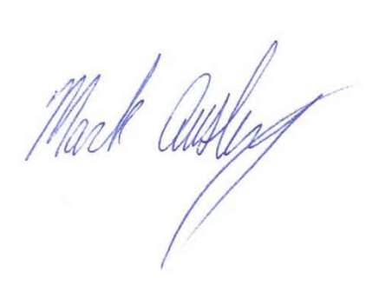 Mark Ausley
Fundraising Committee

